**Project Name: Amazon Clone**

**Nongthombam Guneshwar Singh**

**Edureka Presents**

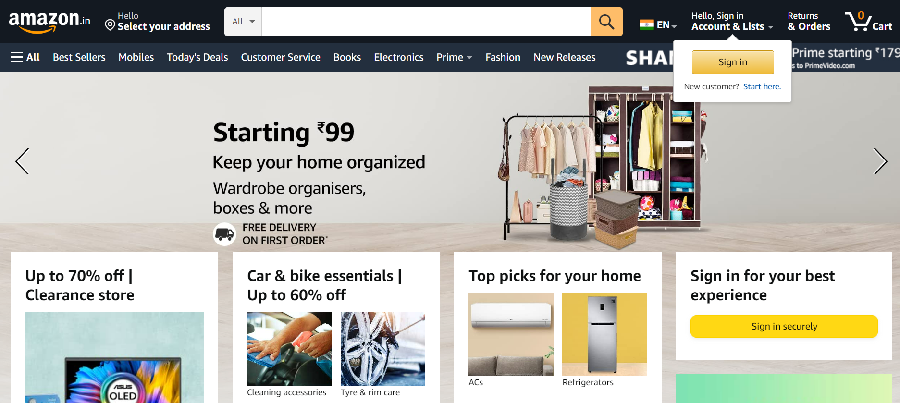

***Overview:***

Amazon.com, Inc is an American [multinational](https://en.wikipedia.org/wiki/Multinational_corporation) [technology company](https://en.wikipedia.org/wiki/Technology_company) which focuses on [e-commerce](https://en.wikipedia.org/wiki/E-commerce), [cloud computing](https://en.wikipedia.org/wiki/Cloud_computing), [digital streaming](https://en.wikipedia.org/wiki/Digital_streaming), and [artificial intelligence](https://en.wikipedia.org/wiki/Artificial_intelligence). It has been referred to as "one of the most influential economic and cultural forces in the world, and is one of the [world's most valuable brands](https://en.wikipedia.org/wiki/List_of_most_valuable_brands).[[6]](https://en.wikipedia.org/wiki/Amazon_(company)#cite_note-6) It is one of the [Big Five](https://en.wikipedia.org/wiki/Big_Tech) American [information technology](https://en.wikipedia.org/wiki/Information_technology) companies, alongside [Alphabet](https://en.wikipedia.org/wiki/Alphabet_Inc.), [Apple](https://en.wikipedia.org/wiki/Apple_Inc.), [Meta](https://en.wikipedia.org/wiki/Meta_Platforms), and [Microsoft](https://en.wikipedia.org/wiki/Microsoft).

***Goals:***

1. Home page
2. Sign in & Sign out Page
3. Product Listing page
4. Add to Cart Page
5. Search Page
6. Payment Page

***Technology Used in Amazon:***

**Front-End:**

1. Html- Hypertext markup language
2. CSS- Cascading Style Sheets

**Code Compilers:**

1. Visual Studio Code
2. Git Bash
3. Git hub

<https://github.com/GuneshwarNong/Project-Document.git>